Flow diagram and code examples

Example 1 – Loop through calculations (0 thru 5)

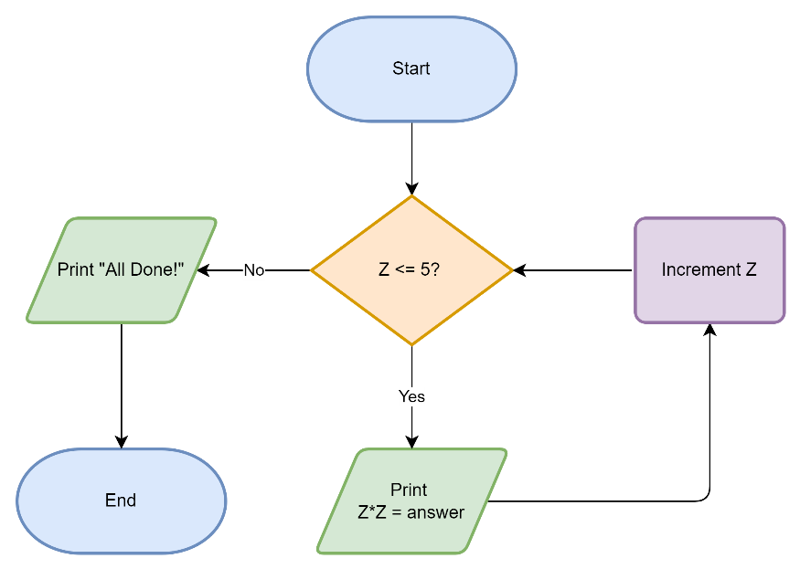

Code solution:



Generated Output:

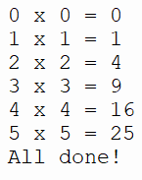

Example 2 – Loop through array (variable) contents

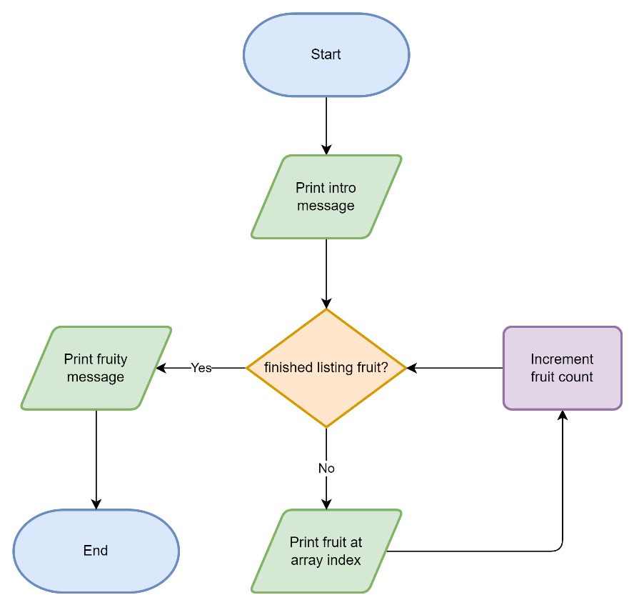

Code solution:

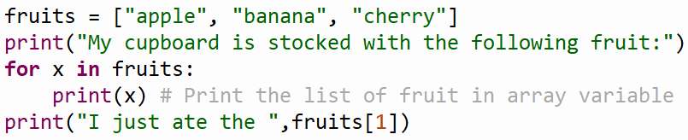

Generated Output:

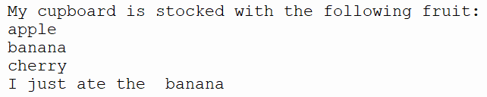

Example 3 – Nested Loops

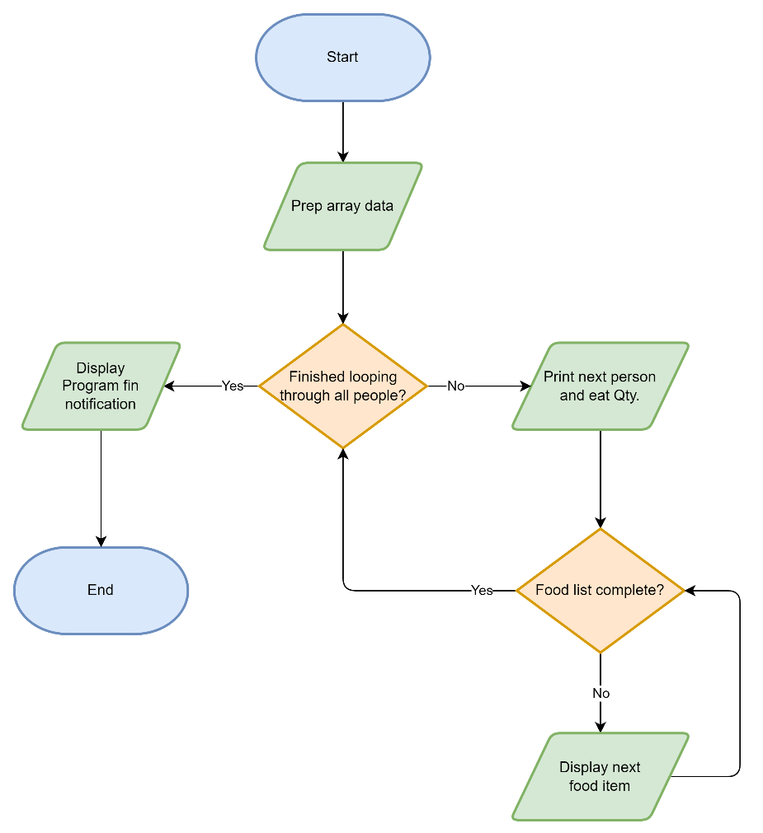

Code solution:

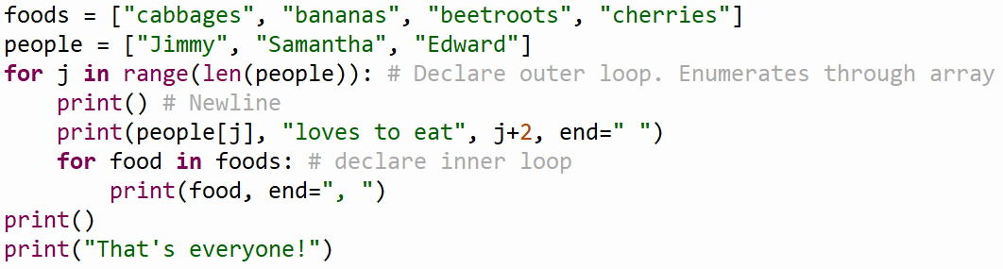

Generated Output:

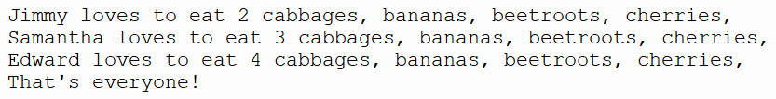

Example 4 – User data input and conditional expressions

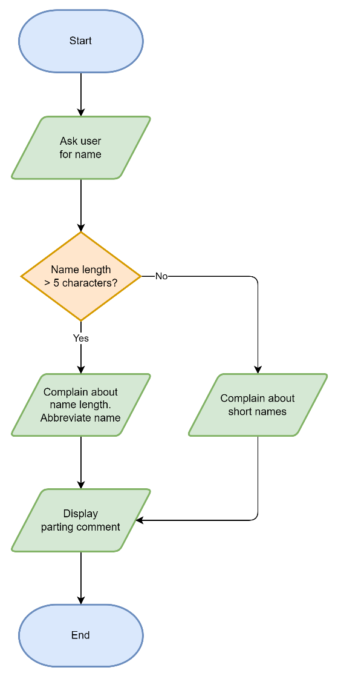

Code solution:

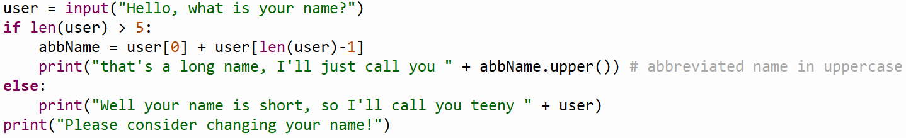

Generated Output:

